EduTutor AI: Personalized Learning with Generative AI and LMS Integration

**1. INTRODUCTION**

**1.1 Project Overview**

EduTutor AI: Personalized Learning with Generative AI and LMS is an intelligent, interactive educational platform that integrates generative AI and a learning management system (LMS) to provide tailored learning experiences. Built using the Streamlit framework and IBM's Granite LLM, EduTutor AI offers student-driven modules, quiz generation, performance tracking, and personalized content delivery.

**1.2 Purpose**

The goal of EduTutor AI is to democratize learning by leveraging AI to generate custom educational materials, adaptive quizzes, and feedback for students and educators. It simplifies content creation, supports real-time learning, and tracks academic progress efficiently.

**2. IDEATION PHASE**

**2.1 Problem Statement**

Students and educators lack access to adaptive, AI-powered tools that can dynamically generate learning content, assessments, and performance analytics based on user needs.

**2.2 Empathy Map Canvas**

- Users: Students, Educators  
- Needs: Personalized content, ease of use, reliable assessments  
- Pains: Static learning material, lack of motivation, no feedback  
- Gains: Interactive learning, AI-generated quizzes, content recommendation

**2.3 Brainstorming**

Ideas considered:  
- Generating learning modules using LLMs  
- Adaptive quiz generator  
- Performance tracking and visualization  
- Role-based LMS dashboard

**3. REQUIREMENT ANALYSIS**

**3.1 Customer Journey Map**

1. User registers and logs in  
2. Learns topics using AI-generated modules  
3. Takes quizzes on the topic  
4. Views performance analytics  
5. Educators monitor student progress

**3.2 Solution Requirement**

- AI model integration (IBM Granite)  
- User registration/authentication  
- Quiz and content generation  
- Performance dashboard

**3.3 Data Flow Diagram**

1. User input → LLM → Generated content/quiz  
2. User interaction → Results storage  
3. Results → Performance visualization

**3.4 Technology Stack**

- Frontend/Framework: Streamlit  
- Backend: Python  
- AI Model: IBM Granite 3.3-2B Instruct  
- Libraries: Transformers, Plotly, Pandas, Torch

**4. PROJECT DESIGN**

**4.1 Problem Solution Fit**

EduTutor AI solves the issue of static, non-personalized learning by using LLMs to dynamically create learning experiences.

**4.2 Proposed Solution**

An application with:  
- AI-generated content based on input topics  
- Quiz generator for self-assessment  
- Separate dashboards for students and educators

**4.3 Solution Architecture**

- User Interface (Streamlit)  
- AI Interaction Layer (Transformers)  
- Storage Layer (JSON files for users/results)  
- Visualization Layer (Plotly, Pandas)

**5. PROJECT PLANNING & SCHEDULING**

**5.1 Project Planning**

- Week 1-2: Ideation and Design  
- Week 3-4: Model Integration and Content Generation  
- Week 5-6: UI and Dashboard Development  
- Week 7: Testing and Documentation

**6. FUNCTIONAL AND PERFORMANCE TESTING**

**6.1 Performance Testing**

Tested quiz generation and model response time. IBM Granite model loads efficiently using GPU. Quiz generation is ~5s on average.

**7. RESULTS**

**7.1 Output Screenshots**

- Login/Register

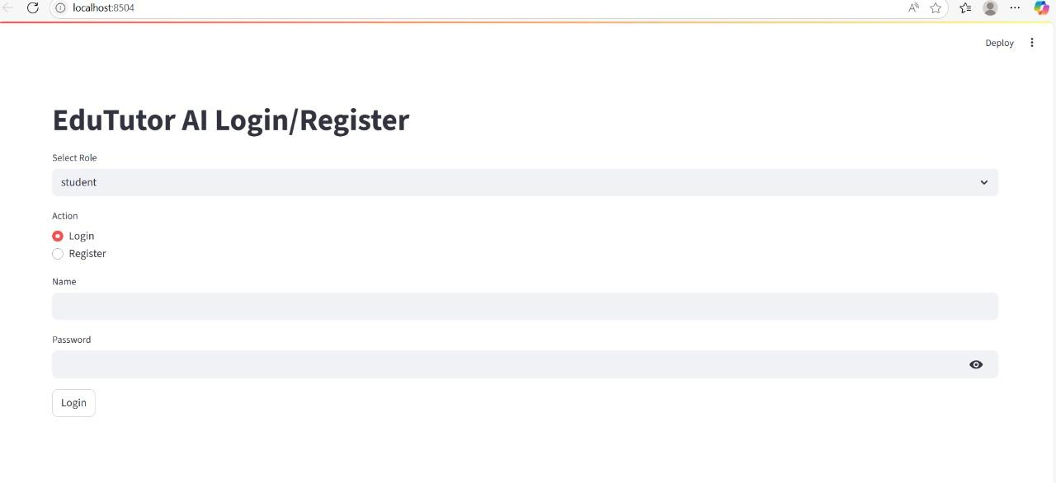

- Course section

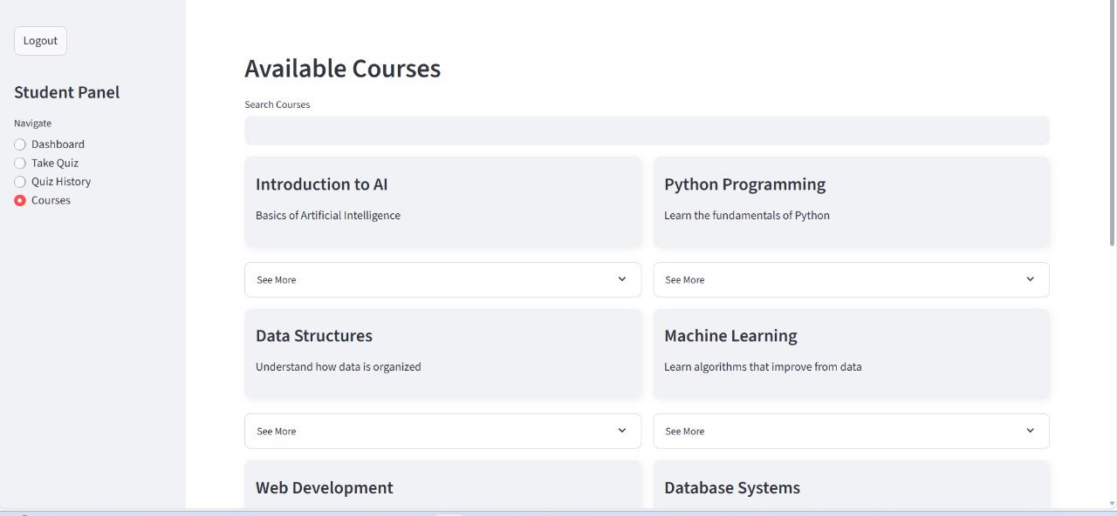  
- Quiz Generation

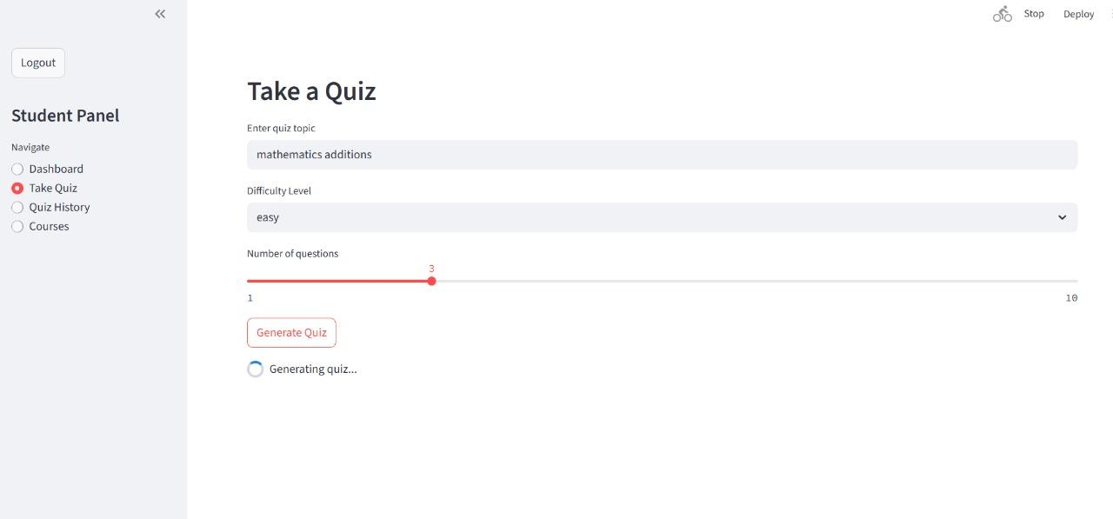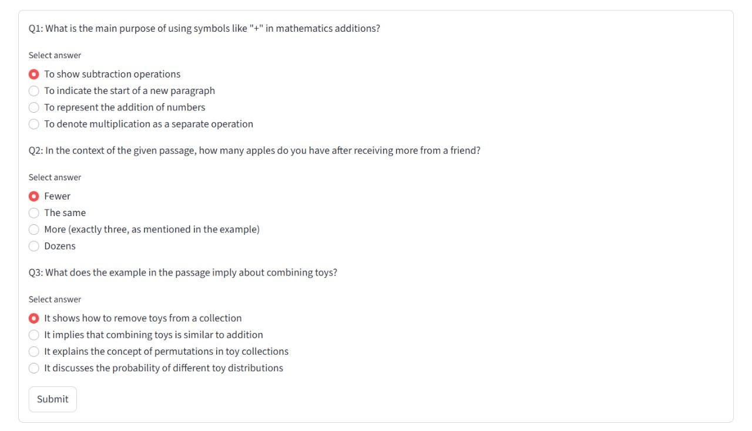

-Quiz History

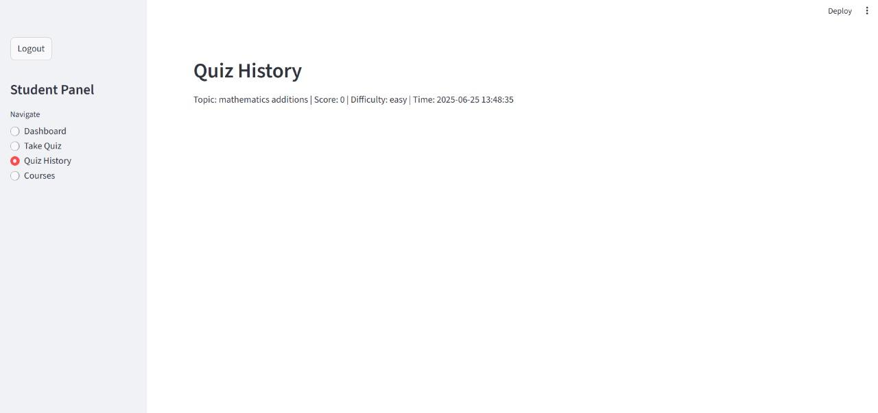

**~educator dashboard:** 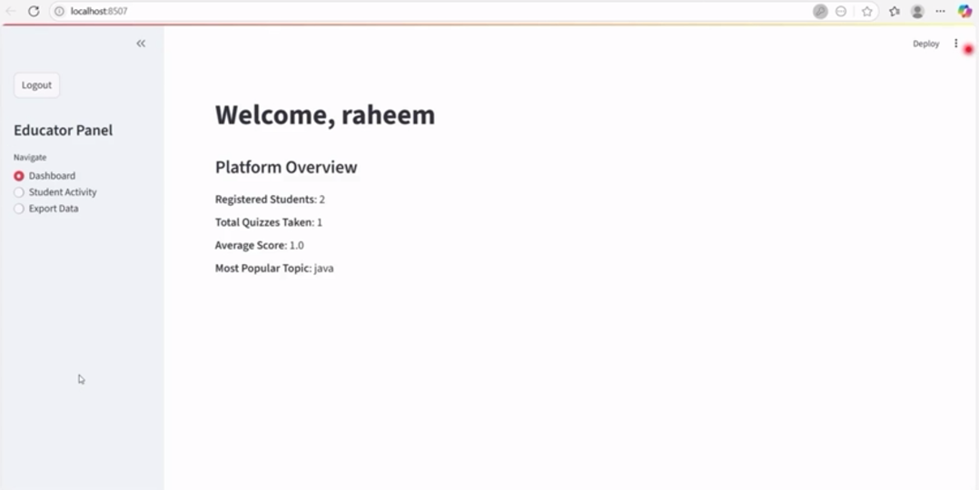

~stdent activity

**~export data**

**8. ADVANTAGES & DISADVANTAGES**

**Advantages**

- Personalized learning  
- Adaptive quizzes  
- Interactive UI

**Disadvantages**

- Model loading time  
- JSON file storage is not scalable

**9. CONCLUSION**

EduTutor AI bridges the gap in personalized learning using generative AI. The tool enables engaging, adaptive learning with real-time assessment and monitoring.

**10. FUTURE SCOPE**

- Use a scalable backend (e.g., Firebase, PostgreSQL)  
- Integrate voice-based learning  
- Real-time collaboration tools for educators

**11. APPENDIX**

**Team Members**

•Talla Naga Harshitha  
• Sk.Jahannar

•Shazia Misba

•Simhadri Nandini

**GitHub & Project Demo Link**

GitHub link:https://github.com/Tallanagaharshitha/edutuor-ai.git

Project Demo link: https://drive.google.com/file/d/1dR-wSohbnUqLrhla17wikA2-f6MKqS5N/view?usp=drivesdk